**AUTOMATED 1-AXIS DRILL ELECTRICAL DATASHEET**

1. L298N MOTOR DRIVER

The module L298n Dual H-bridge, it’s often used with Arduino, it can control 2 DC motors at the same time, and you can control the direction and the speed as well. This module can control a Stepper motor as well.

This dual bidirectional motor driver, is based on the very popular L298 Dual H-Bridge Motor Driver Integrated Circuit. The circuit will allow you to easily and independently control two motors of up to 2A each in both directions. It is ideal for robotic applications and well suited for connection to a microcontroller requiring just a couple of control lines per motor. It can also be interfaced with simple manual switches, TTL logic gates, relays, etc. This board equipped with power LED indicators, on-board +5V regulator and protection diodes.

Product specification

* Input Voltage: 3.2V~40Vdc.
* Driver: L298N Dual H Bridge DC Motor Driver
* Power Supply: DC 5 V - 35 V
* Peak current: 2 Amp
* Operating current range: 0 ~ 36mA
* Operating current range: 0 ~ 36mA

Low: -0.3V ≤ Vin ≤ 1.5V.

High: 2.3V ≤ Vin ≤ Vss.

* Enable signal input voltage range :

Low: -0.3 ≤ Vin ≤ 1.5V (control signal is invalid).

High: 2.3V ≤ Vin ≤ Vss (control signal active).

* Maximum power consumption: 20W (when the temperature T = 75 ℃).
* Storage temperature: -25 ℃ ~ +130 ℃.
* On-board +5V regulated Output supply (supply to controller board i.e. Arduino).
* Size: 3.4cm x 4.3cm x 2.7cm

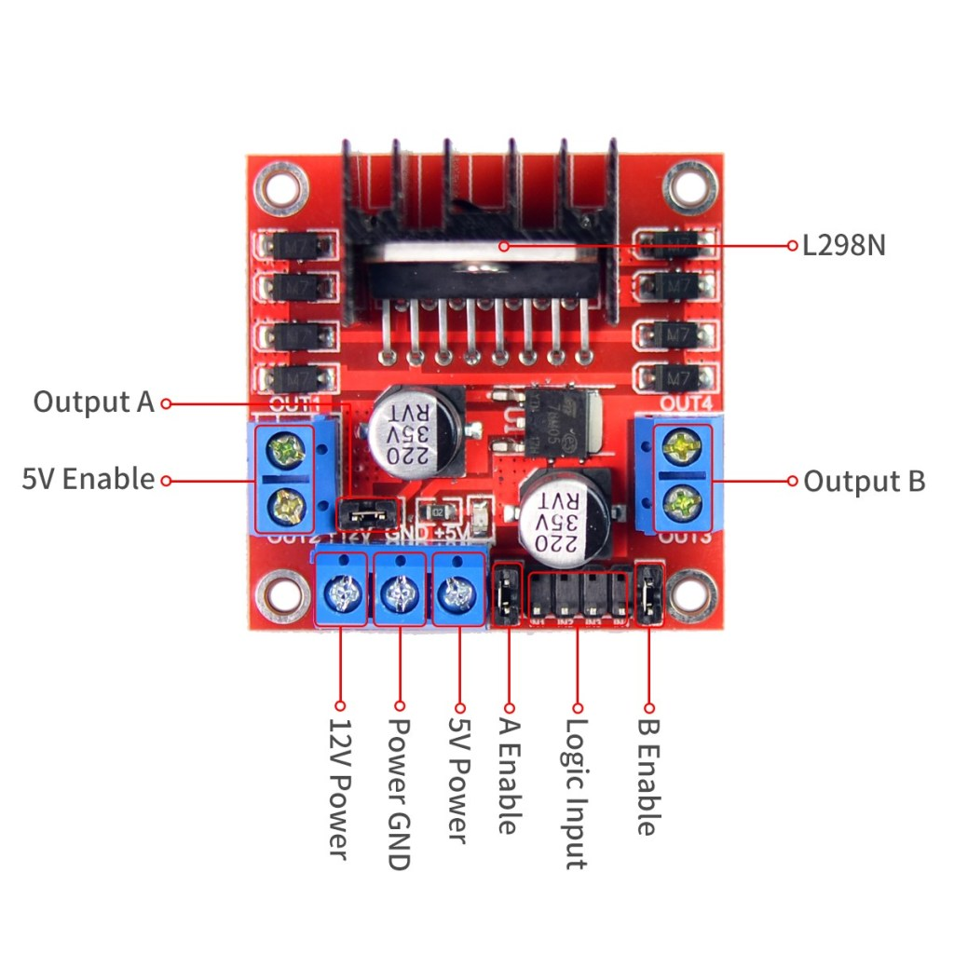

Figure 1 L298n motor driver

* The “Logic Input” pins control the directions: Forward, Backward and Stop, each two of them control A motor.
* 12V power is not always 12V it can be 9V, or it can be powered using up to 47VDC but you have to remove the regulator jumper or you’ll burn it, the regulator can support only up to 12V.
* Enable A/B are for controlling the speed, if their jumpers are kept, the speed will be the maximum, they can handle up to 5V
* The module can be powered using Arduino but that’s not recommended at all, it’s better to use external power, and you can power the Arduino through the module too via the 5V/Gnd pins
* GND pin should always be wired with Arduino.

1. LOAD CELL SENSOR

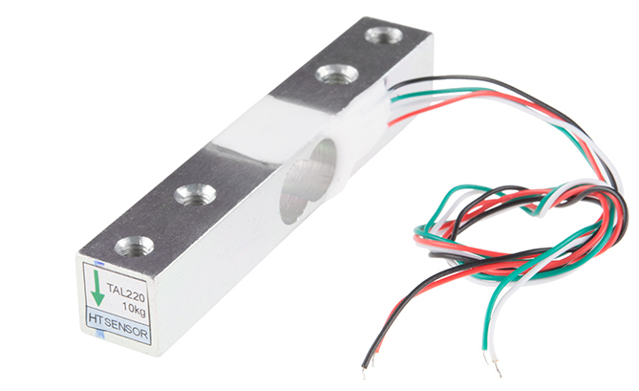

Figure 2 Load cell

A load cell is a force sensing module carefully designed metal structure, with small elements called strain gauges mounted in precise locations on the structure. Load cells are designed to measure a specific force, and ignore other forces being applied. The electrical signal output by the load cell is very small and requires specialized amplification.

Installation

It’s mounted by bolting down the end of the load cell where the wires are attached, and applying force on the other end in the direction of the arrow. Where the force is applied is not critical, as this load cell measures a shearing effect on the beam, not the bending of the beam. If you mount a small platform on the load cell, as would be done in a small scale, this load cell provides accurate readings regardless of the position of the load on the platform.

Calibration

A simple formula is usually used to convert the measured mv/V output from the load cell to the measured force:

Measured Force = A * Measured mV/V + B (offset)

It’s important to decide what unit your measured force is - grams, kilograms, pounds, etc. This load cell has a rated output of 1.0±0.15mv/v which corresponds to the sensor’s capacity of 20kg.

To find A we use

Capacity = A * Rated Output

A = Capacity / Rated Output

A = 20 / 1.0

A = 20

Since the Offset is quite variable between individual load cells, it’s necessary to calculate the offset for each sensor. Measure the output of the load cell with no force on it and note the mv/V output measured by the PhidgetBridge.

Offset = 0 - 20 * Measured Output

Product specification

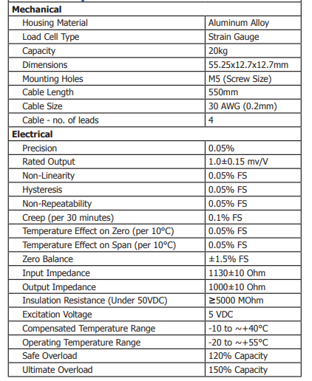

1. HX711 LOAD CELL AMPLIFIER

The HX711 Load Cell Amplifier accepts five wires from the load cell. These pins are labeled with colors; **RED, BLK, WHT, GRN, and YLW**.

These colors correspond to the conventional color coding of load cells, where red, black, green and white wires come from the strain gauge on the load cell and yellow is an optional ground wire that is not hooked up to the strain gauge but is there to ground any small outside EMI (electromagnetic interference). Sometimes instead of a yellow wire there is a larger black wire, foil, or loose wires to shield the signal wires to lessen EMI.

[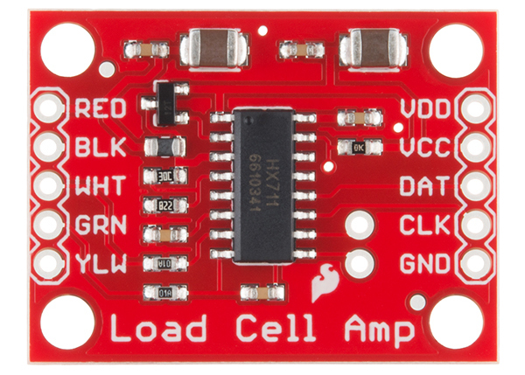](https://cdn.sparkfun.com/assets/learn_tutorials/5/4/6/13879-04_HX711_Breaout_Board.jpg)

Figure 3 Load cell amplifier

In general, each load cell has four strain gauges that are hooked up in a wheatstone bridge formation as shown below.

[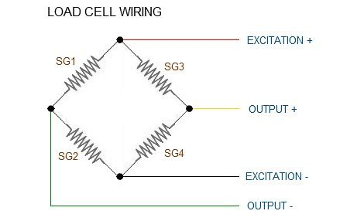](https://cdn.sparkfun.com/assets/learn_tutorials/3/8/3/Wheatstone-Bridge-02.jpg)

|  |  |
| --- | --- |
| **Wheatstone Bridge Node** | **"Typical" Wire Color** |
| Excitation+ (E+) or VCC | RED |
| Excitation- (E-) or GND | BLACK or YELLOW |
| Output- (O-), Signal- (S-), or Amplifier- (A-) | WHITE |
| O+, S+, or A+ | GREEN or BLUE |

Some load cells might have slight variations in color coding such as blue instead of green or yellow instead of black or white if there are only four wires (meaning no wire used as an EMI buffer). You might have to infer a little from the colors that you have or check the datasheet on the load cell, but in general you will usually see these colors.

Once the load cell is hooked up to the amplifier, you can hook up VDD, VCC, DAT, CLK, and GND to a microcontroller such as [Arduino](https://www.sparkfun.com/products/11113) board.

**Note:** VCC is the analog voltage to power the load cell. VDD is the digital supply voltage used to set the logic level.

Serial Interface

Pin PD_SCK and DOUT are used for data retrieval, input selection, gain selection and power down controls. When output data is not ready for retrieval, digital output pin DOUT is high. Serial clock input PD_SCK should be low. When DOUT goes to low, it indicates data is ready for retrieval. By applying 25~27 positive clock pulses at the PD_SCK pin, data is shifted out from the DOUT output pin. Each PD_SCK pulse shifts out one bit, starting with the MSB bit first, until all 24 bits are shifted out. The 25th pulse at PD_SCK input will pull DOUT pin back to high (Figure 1). Input and gain selection are controlled by the number of the input PD_SCK pulses (Table 1). PD_SCK clock pulses should not be less than 25 or more than 27 within one conversion period, to avoid causing serial communication error.

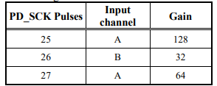

Table 1 Input Channel and Gain Selection

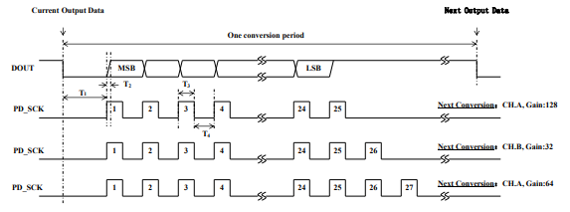

Figure 4 Data output, input and gain selection timing and control

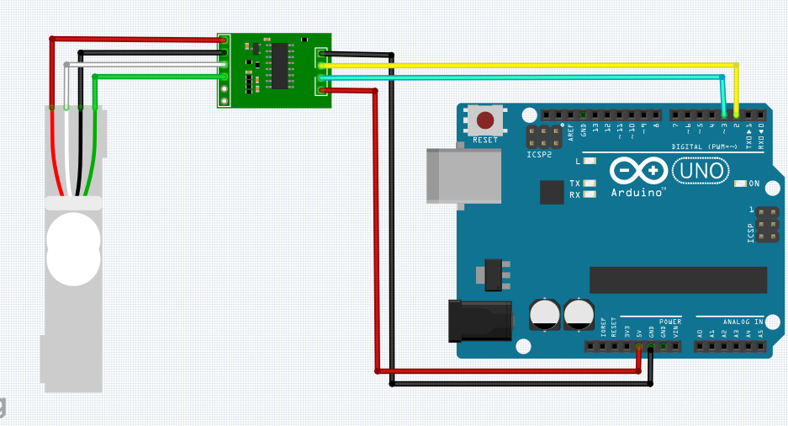

Figure 5; load cell amplifier wiring

1. VIBRATION SENSOR

This module features an adjustable potentiometer, a vibration sensor, and a LM393 comparator chip to give an adjustable digital output based on the amount of vibration.

The potentiometer can be adjusted to both increase and decrease the sensitivity to the desired amount. The module outputs a logic level high (VCC) when it is triggered and a low (GND) when it isn’t.

Additionally, there is an onboard LED that turns on when the module is triggered.

Features

* The default state of the swith is close
* Digital output Supply voltage:3.3V-5V
* On-board indicator LED to show the results
* On-board LM393 chip
* SW-420 based sensor, normally closed type vibration sensor
* Dimension of the board: 3.2cm x 1.4cm

This sensor module produce logic states that depends on vibration and external force applied on it. When there is no vibration this module gives logic LOW output. When it feels vibration then output of this module goes to logic HIGH. The working bias of this circuit is between 3.3V to 5V DC. 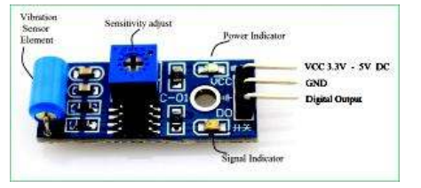

Figure 6; typical vibration sensor

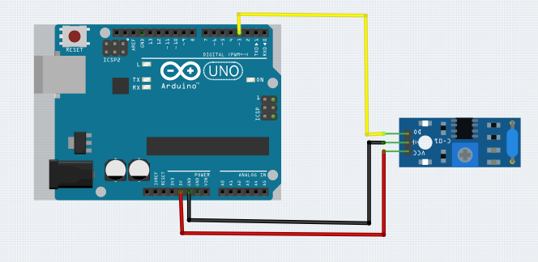

Figure 7 vibration sensor wiring

Sensor Details

SW-420 Single-roller type full induction trigger switch. When no vibration or tilt, the product is ON conduction state, and in the steady state, when a vibration or tilt, the switch will be rendered instantly disconnect the conductive resistance increases, generating a current pulse signal, thereby triggering circuit. These products are completely sealed package, waterproof, dustproof.

Principle

Usually at any angle switch is ON state, by the vibration or movement, the rollers of the conduction current in the switch will produce a movement or vibration, causing the current through the disconnect or the rise of the resistance and trigger circuit. The characteristics of this switch is usually general in the conduction state briefly disconnected resistant to vibration, so it's high sensitivity settings by IC, customers according to their sensitivity requirements for adjustments.

1. MLX90614 TEMPERATURE SENSOR

MLX90614 is IR based contactless temperature sensor that can measure the temperature of a particular object between -70°C – 382.2°C and an ambient temperature of -40°C – 125°C without even making physical contact with an object under observation. It is embedded with an [I2C](https://microcontrollerslab.com/i2c-bus-communication-protocol-tutorial-applications/) port to communicate temperature reading to microcontrollers over an I2C bus. On top of that, it is provided with ESD protection to avoid malfunctioning of the sensor.

The tiny device is highly accurate and precise due to its powerful [ADC](https://microcontrollerslab.com/analog-to-digital-adc-converter-working/). A 17-bit ADC is embedded in the module to output the values with 0.14 ˚C of resolution. Melexis has introduced different versions of this sensor based on input voltage requirements i.e., 3 Volts or 5volts and resolving power for different project requirements. But MLX90614 is a sensitive temperature sensor that has a long list of applications, especially in home automation

## MLX90614 Pinout

This temperature sensor module comes with a 3.3 voltage regulator, I2C Bus with internal pullup resistors to define a default state and a capacitor for noise filtering. The pinout of the non-contact MLX90614 IR Temperature Sensor module is as shown:

### Pin Configuration

MLX90614 has two versions and is available in the TO-39 package. The pin configuration details are listed in a table below:

| **Pin Name** | **Function** |
| --- | --- |
| VCC | Positive power supply pin |
| GND | Reference potential pin |
| SCL | Open drain Serial Clock pin. An I2C line clock pulses pin for data synchronization. |
| SDA | Open drain Serial Data pin. An I2C line to communicate data to the host MCU. |

## Features & Specifications

* Operating Voltage: 3.6 Volts – 5.5 Volts
* Ambient Temperature Range: -40°C – 125°C
* Object Temperature Range: -70°C – 380°C
* Measurement resolution: 0.02°C
* ESD Sensitivity: 2kV
* Sink/Source Current: 25mA
* ADC Resolution: 17 bits
* IR sensor is integrated with an optical filter, a DSP, and a low noise amplifier for fine output digital signals.
* Adaptable for 8-16 Volts applications and can be integrated easily.
* Supports power-saving mode and is available in single and dual versions
* It is a power-efficient and highly sensitive sensor.

Connection Diagram

The following figure shows the connection diagram between MLX90614 temperature sensor and Arduino.

* Connect the power supply pin (Vin) of the temperature sensor to the 5V pin of Arduino and the GND pin of MLX90614 to the GND pin Arduino UNO.
* Connect the SDA and SCL pins of the mentioned IR sensor to the A4 and A5 pins of the Arduino UNO for transferring data serially. A4 and A5 pins of Arduino also share alternate function of SDA and SCL pins of I2C port of Arduino Uno.

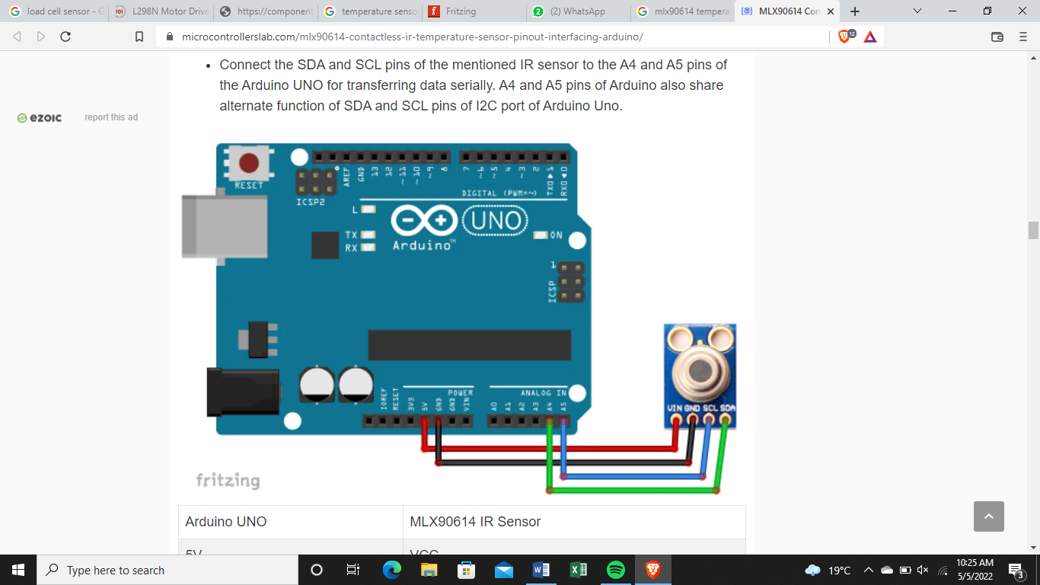

|  |  |
| --- | --- |
| Arduino UNO | MLX90614 IR Sensor |
| 5V | VCC |
| GND | GND |
| SDA | A4 |
| SCL | A5 |

1. BIPOLAR STEPPER MOTOR

A [stepper motor](https://www.electrical4u.com/stepper-motor-drive/) is a [brushless DC motor](https://www.electrical4u.com/brushless-dc-motors/) that divides a full rotation into several equal steps of 1.8 degrees thus they can make up to 200 steps in one rotation. The motor’s position can then be directed to move and hold at one of these steps without any position sensor for feedback.

Bipolar stepper motors are a type of stepper motor with a single winding per phase and no center tap unlike a unipolar stepper motor.

The [DC current](https://www.electrical4u.com/dc-current/) in a winding needs to be reversed to reverse a magnetic pole and allow the motor to function. A H-bridge IC is used to drive the bipolar stepper motor because of the following reasons;

* They can reverse the polarity of the stator coils.
* They are capable of handling high current that is drawn by the stepper motor since the microcontroller could only handle up to 15 mA.
* They can protect the microcontroller pins against high spikes that results when the coil current changes direction.

Bipolar motor driver circuit interface

